/* ASSIGNMENT NO. - 1

Problem Statement:- Implementation of Conflation Algorithm */

#include<stdio.h>
#include<conio.h>
#include<string.h>

char stopwords[][6]={"the","a","an","as","at","is","if","it","in","and","of","on","or","we","by","they","to","for","from","also","our","this","only","that","have","into","its"};
char stem[][7] = {"ing","ly","able","ation"};
FILE *src,*dest;

voiddisplay(charfname[]);
voidstep1(charfname[]);
voidstep2(charfname[]);
voidstep4();

voidmain()
{
charfilename[10];

clrscr();
printf("Enter the source filename = ");
fflush(stdin);
gets(filename);

printf("\n\nThe source file contents are :- \n\t");
display(filename);
getch();

step1(filename);
printf("\n\n\n\nThe source file contents after REMOVING STOP WORDS are :- \n\t");
display("step1.txt");
getch();

step2("step1.txt");
printf("\n\n\n\nThe file contents after SUFFIX STEMMING are :- \n\t");
display("step2.txt");
getch();

step4();
getch();

}

voiddisplay(charfname[])
{
charbuf[50];
src =fopen(fname,"r");
if(src==NULL)
{
printf("\n\nFile not found.....");
getch();
exit(0);
}
else
{
while(fscanf(src,"%s",buf)!=EOF)
{
printf("%s ",buf);
}
fclose(src);
}
}

voidstep1(charfname[])
{
chartok1[15],buf[20],tok2[15],tok3[15];
int i;

src =fopen(fname,"r");
if(src==NULL)
{
printf("\n\nFile not found....");
getch();
exit(0);
}
else
{
dest =fopen("step1.txt","w");
if(dest==NULL)
{
printf("\n\nError in opening file.......");
getch();
exit(0);
}
else
{
while(fscanf(src,"%s ",buf)!=EOF)
{
sscanf(buf,"%s %s",tok1,tok2);
for(i=0;i<=26;i++)
{
if(strcmpi(tok1,stopwords[i])==0)
break;
}
if(i==27)
{
//To remove the punctuation
if(tok1[strlen(tok1)-1]=='.'||tok1[strlen(tok1)-1]==',')
{
tok1[strlen(tok1)-1] ='\0';
}
fprintf(dest,"%s ",tok1);
}
}
}
}
fcloseall();
}

voidstep2(charfname[])
{
chartok1[17],buf[20],tok2[17],*tok3;
int i,j;

src =fopen(fname,"r");
if(src==NULL)
{
printf("\n\nFile not found....");
getch();
exit(0);
}
else
{
dest =fopen("step2.txt","w");
if(dest==NULL)
{
printf("\n\nError in opening file.......");
getch();
exit(0);
}
else
{
while(fscanf(src,"%s ",buf)!=EOF)
{
sscanf(buf,"%s ",tok1);
for(i=0;i<=3;i++)
{
if(strstr(tok1,stem[i]))
{
tok3 =strrev(tok1);
j =strlen(stem[i]);
tok3 =&tok3[j];
tok3 =strrev(tok3);

//Context Rule #1 : For words like 'ignoring'
if(strcmp(stem[i],"ing")==0&&tok3[strlen(tok3)-1]=='r')
strcat(tok3,"e");

//Context Rule #2 : For words like 'authorization'
if(strcmp(stem[i],"ation")==0&&tok3[strlen(tok3)-1]=='z')
strcat(tok3,"e");

//Context Rule #3 : For words like 'registration'
if(strcmp(stem[i],"ation")==0&&tok3[strlen(tok3)-1]=='r')
strcpy(&tok3[strlen(tok3)-1],"er");

fprintf(dest,"%s ",tok3);
break;
}
}
if(i==4)
{
//Context Rule #4 : For avoiding words like 'tremendous'
if(tok1[strlen(tok1)-1]=='s'&&tok1[strlen(tok1)-2]!='u')
tok1[strlen(tok1)-1] ='\0';

fprintf(dest,"%s ",tok1);
}
}
}
}
fcloseall();
}

voidstep4()
{
chartok1[17],buf[50],arr[100][15];
int i=0,j,cnt,k,l=0;

src =fopen("step2.txt","r");
if(src==NULL)
{
printf("\n\nFile not found....");
getch();
exit(0);
}
while(fscanf(src,"%s ",buf)!=EOF)
{
sscanf(buf,"%s ",tok1);
strcpy(arr[i],tok1);
i++;
}
printf("\n\nFrequency Count : \n");
for(j=0;j<i;j++)
{
cnt=1;
for(k=j+1;k<i;k++)
{
if(strcmpi(arr[j],arr[k])==0)
{
cnt=cnt++;
for(l=k;l<i;l++)
strcpy(arr[l],arr[l+1]);
i--;
}
}
//strcpy(a[j],arr[j]);
printf("\n%s\t\t\t%d",arr[j],cnt);
}
}

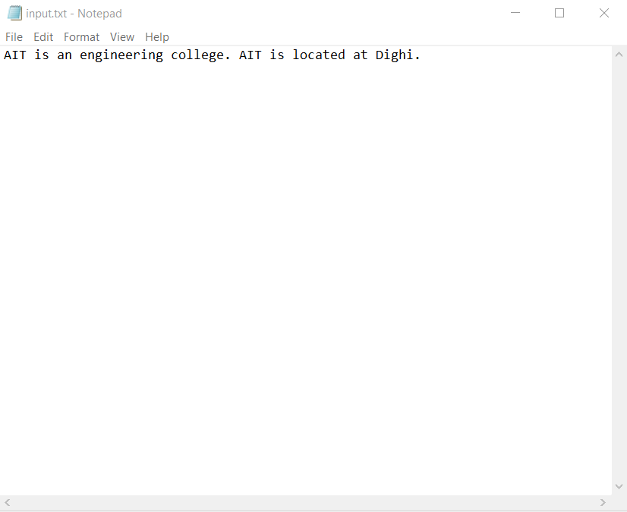
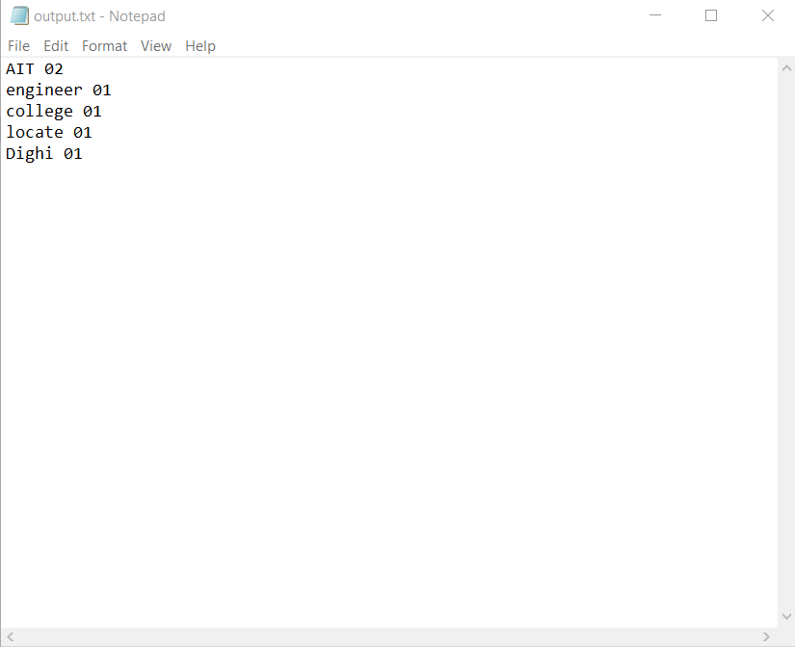

/* Assignment No.:- 2
Title: - Implementation of Single Pass Algorithm for clustering.
Class:-B.E.I.T.
*/

#include<stdio.h>
#include<conio.h>
#defineDIFF10
#defineMAX10
floatsM[MAX][MAX]={0},Treshold;
int objNo,idx[MAX];
voidprocess_non();
voidoverlap();
voidcalcr(int);
intCluster[MAX][MAX]={0};
voidmain()

{
int i,j,ch;
clrscr();
printf("\nEnter no. Of Objects");
scanf("%d",&objNo);
printf("\nEnter Treshold Value");
scanf("%f",&Treshold);
printf("\nEnter Values for Similarity Matrix==>");
for(i=0;i<objNo;i++)
sM[i][i]=1.0;

for(i=0;i<objNo;i++)
{
for(j=i+1;j<objNo;j++)
if(i!=j)
{
printf("\nSimilarity Matrix[%d][%d]=>",i+1,j+1);
scanf("%f",&sM[i][j]);
sM[j][i]=sM[i][j];
}
}
for(i=0;i<objNo;i++)
{ printf("\n");
for(j=0;j<objNo;j++)
{
//printf("\nSimilarity Matrix[%d][%d]=>",i+1,j+1);
printf("%.1f",sM[i][j]);
}
}
clrscr();
while(1)
{
printf("\nMENU");
printf("\n[1]NON OVERLAPPING");
printf("\n[2]OVERLAPPING");
printf("\nEnter ur choise==>");
scanf("%d",&ch);
switch(ch)
{
case1:
process_non();
break;
case2:
overlap();
//calcr(0);
break;
case3:
exit(0);
break;
}
}
}
voidprocess_non()
{
int i,j;
int k,l=0,t,x;
int count=0;
printf("\nSimilarity MAtrix=>\n");
disp(sM,0);

for(i=0;i<objNo;i++)
{
if(count==0) //first object
{ Cluster[count][0]=1;
Cluster[count][1]=i;
count++;
}
else //all other objects
{
for(j=0;j<count;j++) //For all clusters
{
t=Cluster[j][1];
if(sM[t][i]>Treshold) //compare sim(obj, CR),Threshold
{
x=Cluster[j][0];
Cluster[j][x+1]=i;
Cluster[j][0]+=1;
calcr(j);
break;
}
}//for
if(j==count)
{ Cluster[count][0]=1;
Cluster[count][1]=i;
count++;
}
}//else
}

printf("\nCLUSTER\n");
for(i=0;i<count;i++)
{ printf("\n");
x=Cluster[i][0];
printf("%d",Cluster[i][0]);
for(j=1;j<=x;j++)
{
printf("%d\t",Cluster[i][j]+1);
}
}
}

disp(floatsm1[MAX][MAX],intflag)
{
int i,j;
for(i=0;i<objNo;i++)
{
if(flag)
{
printf("\nCluster[%d]=>",i+1);
for(j=0;j<idx[i];j++)
{
printf("\t%.2f",sm1[i][j]);
}
}
else
{
printf("\n[%d]=>",i+1);
for(j=0;j<objNo;j++)
{
printf("\t%.2f",sm1[i][j]);
}
}
}
getch();
}

voidoverlap()
{
for(i=0;i<objNo;i++)
{ flag=0;
if(count==0) //first object
{flag=1;
Cluster[count][0]=1;
Cluster[count][1]=i;
count++;
}
else //all other objects
{ for(j=0;j<count;j++)
{ t=Cluster[j][1];
if(sM[t][i]>Treshold)
{flag=1;
x=Cluster[j][0];
Cluster[j][x+1]=i;
Cluster[j][0]+=1;
calcr(j);
//break;
}
}//for
if(flag==0)
{
Cluster[count][0]=1;
Cluster[count][1]=i;
count++;
} }//else }
printf("\nCLUSTER\n");
for(i=0;i<count;i++)
{ printf("\n");
x=Cluster[i][0];
printf("%d",Cluster[i][0]);
for(j=1;j<=x;j++)
{
printf("%d\t",Cluster[i][j]+1);
}
}
}

voidcalcr(int j)
{
float min=0.0;
int temp,y,z,x,cr=0,index=1;

for(y=1;y <=Cluster[j][0];y++)
{ x=0;
for(z=1;z<=Cluster[j][0];z++)
{ if(y!=z)
x= x+sM[y][z];
}
// if(min == (x/Cluster[j][0]) )

if( min < (x/Cluster[j][0]))
{ min = x/Cluster[j][0];
cr=Cluster[j][y];
index=y;
}
min=0.0;
}

temp =Cluster[j][1];
Cluster[j][1]= cr;
Cluster[j][index] = temp;
}

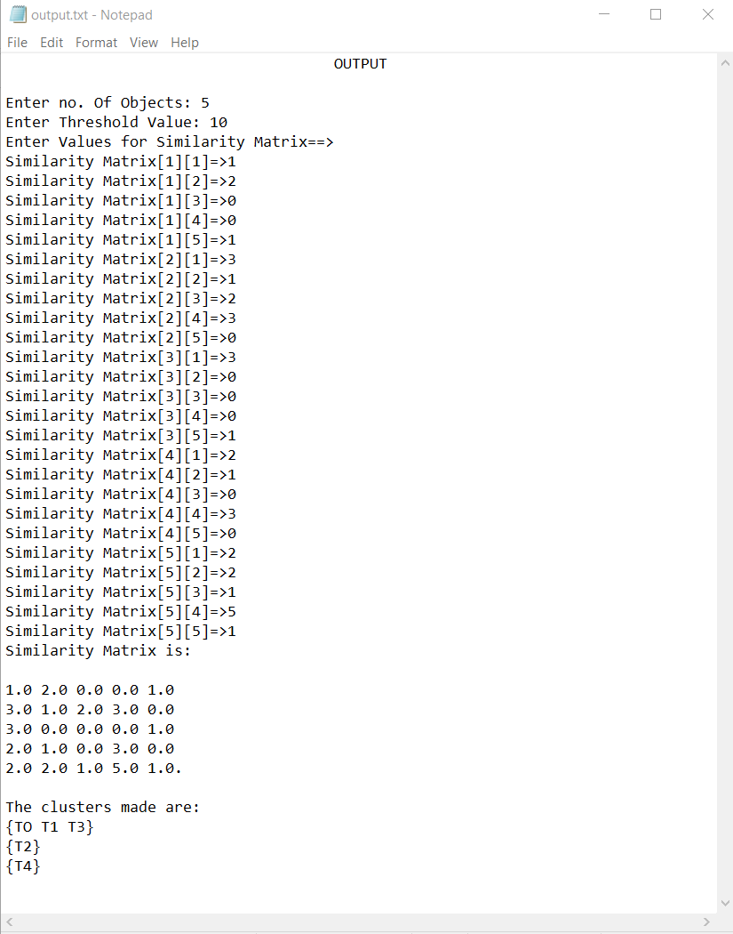

Assignment 3

importjava.io.BufferedReader;
importjava.io.File;
importjava.io.FileReader;
importjava.io.IOException;
importjava.util.ArrayList;
importjava.util.Arrays;
importjava.util.HashMap;
importjava.util.HashSet;
importjava.util.LinkedList;
importjava.util.List;
importjava.util.Map;
importjava.util.Set;
importjava.util.*;

publicclassInvertedIndex7
{
List<String>stopwords=Arrays.asList("a", "able", "about",
"across", "after", "all", "almost", "also", "am", "among", "an",
"and", "any", "are", "as", "at", "be", "because", "been", "but",
"by", "can", "cannot", "could", "dear", "did", "do", "does",
"either", "else", "ever", "every", "for", "from", "get", "got",
"had", "has", "have", "he", "her", "hers", "him", "his", "how",
"however", "i", "if", "in", "into", "is", "it", "its", "just",
"least", "let", "like", "likely", "may", "me", "might", "most",
"must", "my", "neither", "no", "nor", "not", "of", "off", "often",
"on", "only", "or", "other", "our", "own", "rather", "said", "say",
"says", "she", "should", "since", "so", "some", "than", "that",
"the", "their", "them", "then", "there", "these", "they", "this",
"tis", "to", "too", "twas", "us", "wants", "was", "we", "were",
"what", "when", "where", "which", "while", "who", "whom", "why",
"will", "with", "would", "yet", "you", "your");

Map<String, List<Tuple>>index=newHashMap<String, List<Tuple>>();
List<String>files=newArrayList<String>();

publicvoidindexFile(Filefile,List<Tuple>idx ) throwsIOException
{
intfileno=files.indexOf(file.getPath());
if (fileno ==-1)
{
files.add(file.getPath());
fileno =files.size();
}
System.out.println();
intpos=0;intcnt=0;
BufferedReaderreader=newBufferedReader(newFileReader(file));
//List<Tuple> idx = new LinkedList<Tuple>();
Tuplet1,t2;
for (Stringline=reader.readLine(); line !=null; line =reader.readLine())
{
for (String_word:line.split("\\W+"))
{
Stringword=_word.toLowerCase();
pos++;
cnt++;
if (stopwords.contains(word))
{
//pos=pos+word.length()+1;
continue;
}
List<Tuple>idx1=index.get(word); //search in stopword
if (idx1 ==null)
{
//index.put(word,idx);
t2=newTuple(fileno,pos,word);
t1=t2;
intk;
for(k=0;k<idx.size();k++)
{
t1=idx.get(k);
if(t1.search1(word))
break;
}
if(k==idx.size())
idx.add(t2);
else
t1.addpre(pos);
//pos=pos+word.length()+1;
}

}
}
System.out.println("indexed "+file.getPath() +" "+ pos +" words excluding stopwords" );
}
publicstaticvoidmain(String[] args)
{
try
{
InvertedIndex7idx=newInvertedIndex7();
List<List>head=newLinkedList<List>();
List<Tuple>h1;
Tuplet1,l,t2;
for (inti=0; i <args.length; i++)
{
h1=newLinkedList<Tuple>();
System.out.println("File name :"+args[i]);
System.out.println();
idx.indexFile(newFile(args[i]),h1);
System.out.println();
System.out.println("\n\ndocument no. (table no.) "+i);
System.out.println("\nTerms\tPosition\tFrequency\n");
for(intk=0;k<h1.size();k++)
{
t1=h1.get(k);
t1.display(1);
}
head.add(h1);
}
System.out.println("\n\ntable no. 3 \n");
System.out.println("Terms\t\tFile no.\n");
for(intk=0;k<head.size();k++)
{
h1=head.get(k);
for(intj=0;j<h1.size();j++)
{
t1=h1.get(j);
t1.display(3);
}
}
List<Tuple>headsort1=newLinkedList<Tuple>();
//h1=(head.get(0));
//headsort1=l=h1.get(0)
for(inta1=0;a1<head.size();a1++)
{
//l=new LinkedList<Tuple>();
h1=(head.get(a1));
for(intj=0;j<h1.size();j++)
{
l=h1.get(j);
intflag=0;
for(intk=0;k<headsort1.size();k++)
{
t2=headsort1.get(k);
Stringstr1=t2.getName();
Stringstr2=l.getName();
intresult=str1.compareToIgnoreCase(str2);
if(result>0)
{
headsort1.add(k,l);
flag=1;
break;
}

}
if(flag==0)
headsort1.add(l);
}
}
System.out.println("\n\nsorted table ..Table no. 4\n");
System.out.println("Terms\t\tFile no.\n");
for(intk=0;k<headsort1.size();k++)
{
//System.out.println("gga22");
t1=headsort1.get(k);
t1.display(4);

}
System.out.println("\n\ntable no 5 :\n");
System.out.println("Terms\t\tFile no.\t\tFrequency\n");
// List<Tuple> table5 = new LinkedList<Tuple>();
//table5=headsort1;
//LinkedList(Collection<? extends Tuple> headsort1);
intsz=headsort1.size();
for(intk=0;k<sz-1;k++)
{
//System.out.println("gga22");
t1=headsort1.get(k);
t2=headsort1.get(k+1);
Stringstr1=t1.getName();
Stringstr2=t2.getName();
if(str1.equals(str2))
{
t1.addond(t2);
headsort1.remove(k+1);
sz--;
}
//int result = str1.compareToIgnoreCase(str2);
t1.display(5);

}
t1=headsort1.get(sz-1);
t1.display(5);
System.out.println("\n\nTable no. 6");
System.out.println("Terms\t\tNo. of document\t\t Total Frequency\n");
for(intk=0;k<headsort1.size();k++)
{
//System.out.println("gga22");
t1=headsort1.get(k);
t1.display(6);

}
System.out.println("\n\nTable no. 7...Postings");
System.out.println("\n\ndocument no.\t\tPostions\tFrequency\n");
for(intk=0;k<headsort1.size();k++)
{
//System.out.println("gga22");
t1=headsort1.get(k);
t1.display(7);

}

/* ObjectComparator comparator1 = new ObjectComparator();
Collections.sort(head, comparator1);
for(int k=0;k<head.size();k++)
{
t1=head.get(k);
t1.display();
}*/
} catch (Exceptione) {e.printStackTrace();}
}

/*public class ObjectComparator implements Comparator<Tuple>
{
@Override
public int sort(Tuple obj1, Tuple obj2)
{
return obj1.getName().compareTo(obj2.getName());
}

}*/
privateclassTuple
{
privateintfileno[]=newint[20];
privateintfln=0;
privateintposition[]=newint[20];
privateintloc;
privateintpos_i=0;
privateintfreq=0;
privateStringword;
publicTuple(intfileno, intposition,Stringword)
{
this.fileno[fln++] = fileno;
this.position[this.pos_i++] = position;
this.word=word;
this.freq++;
}
publicStringgetName(){ return word;}
publicbooleansearch1(Stringw1)
{
if(word.equals(w1))
returntrue;
returnfalse;
}
publicvoidaddond(Tuplet2)
{
fileno[fln++]=t2.fileno[t2.fln];
freq++;
}
publicvoidaddpre(intposition)
{
this.position[this.pos_i++] = position;
this.freq++;
}
publicvoiddisplay(intt)
{
System.out.println();
if(t==1||t==7)
{
if(t!=7)
System.out.print(""+this.word+"\t\t");
if(t==7)
{
for(inti=0;i<this.fln;i++)
System.out.print("D"+this.fileno[i]+",");
}
System.out.print("\t\t");
for(inti=0;i<this.pos_i;i++)
System.out.print(""+this.position[i]+",");
System.out.print("\t\t"+this.freq+"\t\t");
}
if(t==3||t==4||t==5||t==6)
{
System.out.print(""+this.word+"\t\t");
if(t!=6)
for(inti=0;i<this.fln;i++)
System.out.print("D"+this.fileno[i]+",");
else
System.out.print(this.fln);
if(t!=3||t!=4)
System.out.print("\t\t"+this.freq+"\t\t");
}
//System.out.print("\t\tD"+this.fileno);
System.out.println();
}
}

}

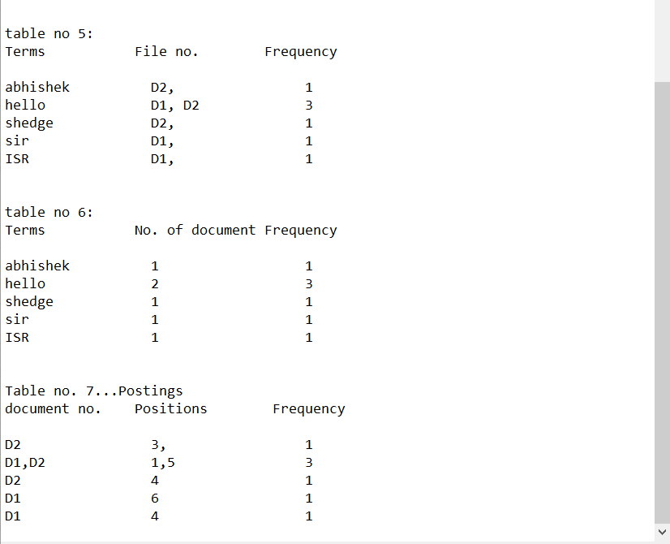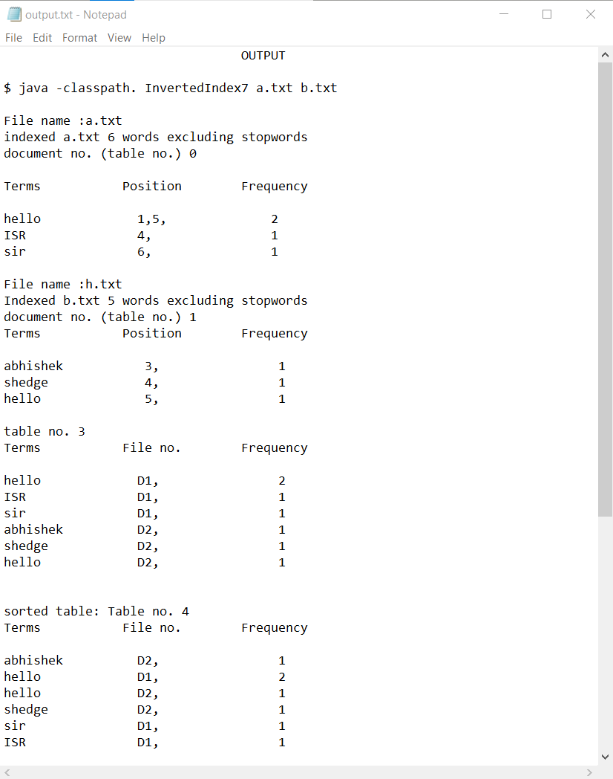

Assignment 4
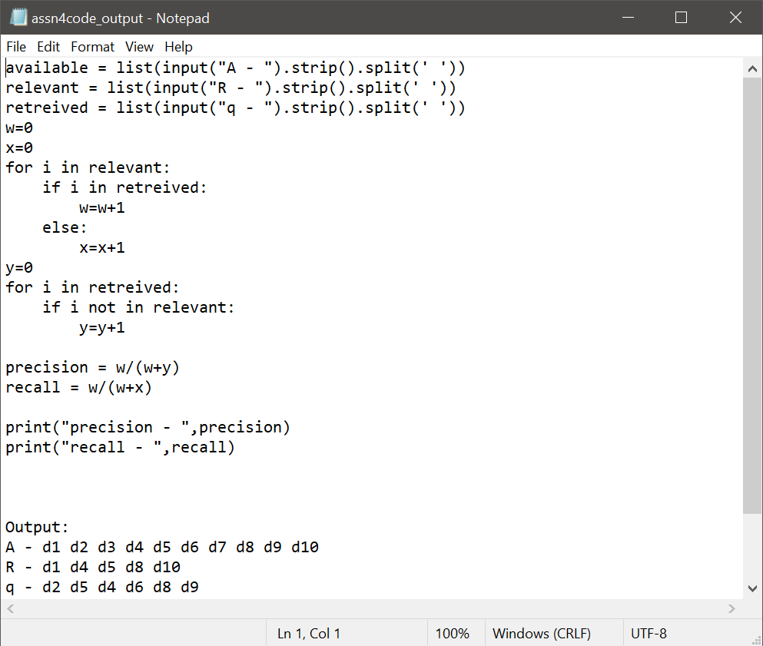
Precision:0.5
Recall-0.571

Assignment 5

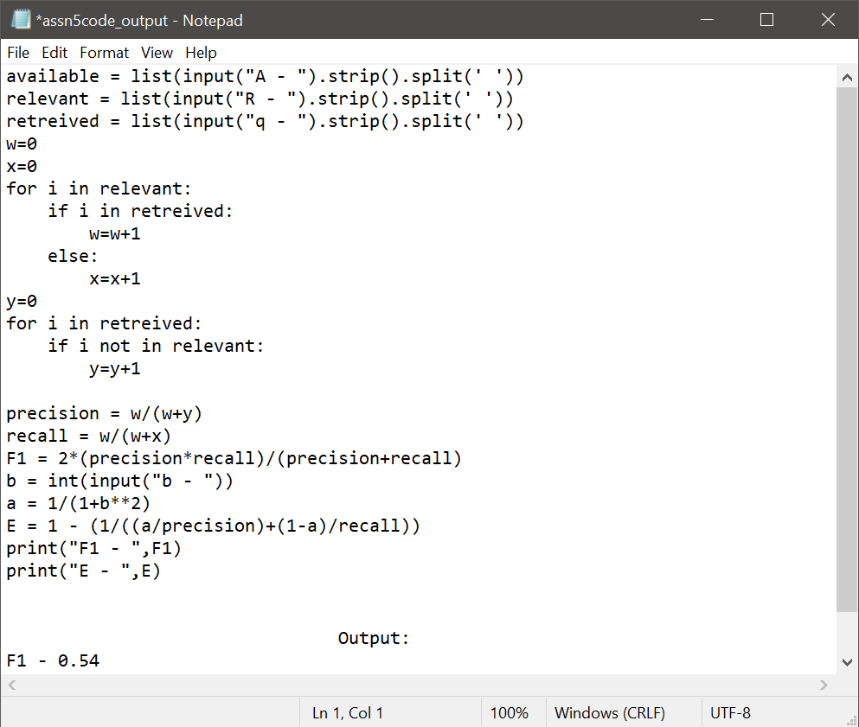

F1=0.54
E=0.48

Assignment 6
importjava.awt.*;
importjava.awt.image.BufferedImage;

importjava.io.*;

importjava.util.*;

importjavax.imageio.ImageIO;

publicclassFeatureExtraction {

privatestaticBufferedImageorignal,answer;

publicstaticvoidmain(String[] args) throwsIOException{

Fileorignal_f=newFile("osum.jpg");
orignal =ImageIO.read(orignal_f);
answer=imageHistogram(orignal);
writeImage("featureExtraction");

}

privatestaticvoidwriteImage(Stringoutput) throwsIOException {
Filefile=newFile(output+".jpg");
ImageIO.write(answer, "jpg", file);
}

privatestaticintcolorToRGB(intalpha, intred, intgreen, intblue) {

intnewPixel=0;
newPixel += alpha; newPixel = newPixel <<8;
newPixel += red; newPixel = newPixel <<8;
newPixel += green; newPixel = newPixel <<8;
newPixel += blue;

return newPixel;

}

publicstaticBufferedImageimageHistogram(BufferedImageinput) {

BufferedImageredGraph=newBufferedImage(input.getWidth(),input.getHeight(),input.getType());
for(inti=0; i<input.getWidth(); i++) {
for(intj=0; j<input.getHeight(); j++) {

intalpha=newColor(input.getRGB (i, j)).getAlpha();
intred=newColor(input.getRGB (i, j)).getRed();
intgreen=newColor(input.getRGB (i, j)).getGreen();
intblue=newColor(input.getRGB (i, j)).getBlue();
redGraph.setRGB(i, j, colorToRGB(alpha, red,0,0));

}
}

return redGraph;

}
}

Output
Height of the image is 542
Width of the image is 720
Average red content is 84
Average Green colour content is 84
Average Blue colour content is 84

Image after replacing all the pixels by the average of the RGB value of pixel

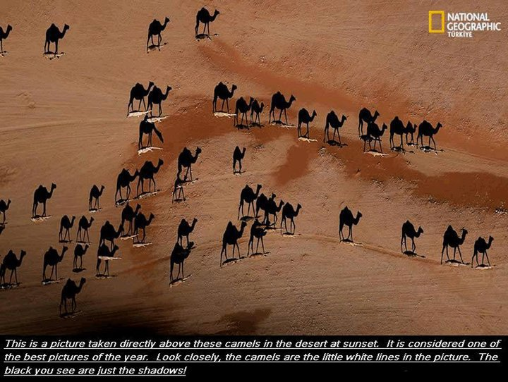

Ass6 :another implementation
importjava.awt.BorderLayout;
importjava.awt.Color;
importjava.awt.EventQueue;
importjava.awt.Paint;
importjava.awt.event.ActionEvent;
importjava.awt.image.BufferedImage;
importjava.awt.image.Raster;
importjava.io.IOException;
importjava.net.URL;
importjavax.imageio.ImageIO;
importjavax.swing.AbstractAction;
importjavax.swing.ImageIcon;
importjavax.swing.JCheckBox;
importjavax.swing.JFrame;
importjavax.swing.JLabel;
importjavax.swing.JPanel;
importorg.jfree.chart.ChartFactory;
importorg.jfree.chart.ChartPanel;
importorg.jfree.chart.JFreeChart;
importorg.jfree.chart.plot.DefaultDrawingSupplier;
importorg.jfree.chart.plot.PlotOrientation;
importorg.jfree.chart.plot.XYPlot;
importorg.jfree.chart.renderer.xy.StandardXYBarPainter;
importorg.jfree.chart.renderer.xy.XYBarRenderer;
importorg.jfree.data.statistics.HistogramDataset;

/**
* @see https://stackoverflow.com/q/40537278/230513
* @see https://stackoverflow.com/q/11870416/230513
* @see https://stackoverflow.com/a/28519356/230513
*/
publicclassHistogram {

privatestaticfinalintBINS=256;
privatefinalBufferedImageimage=getImage();
privateHistogramDatasetdataset;
privateXYBarRendererrenderer;

privateBufferedImagegetImage() {
try {
returnImageIO.read(newURL(
"https://i.imgur.com/kxXhIH1.jpg"));
} catch (IOExceptione) {
e.printStackTrace(System.err);
}
returnnull;
}

privateChartPanelcreateChartPanel() {
// dataset
dataset =newHistogramDataset();
Rasterraster=image.getRaster();
finalintw=image.getWidth();
finalinth=image.getHeight();
double[] r=newdouble[w * h];
r =raster.getSamples(0, 0, w, h, 0, r);
dataset.addSeries("Red", r, BINS);
r =raster.getSamples(0, 0, w, h, 1, r);
dataset.addSeries("Green", r, BINS);
r =raster.getSamples(0, 0, w, h, 2, r);
dataset.addSeries("Blue", r, BINS);
// chart
JFreeChartchart=ChartFactory.createHistogram("Histogram", "Value",
"Count", dataset, PlotOrientation.VERTICAL, true, true, false);
XYPlotplot= (XYPlot) chart.getPlot();
renderer = (XYBarRenderer) plot.getRenderer();
renderer.setBarPainter(newStandardXYBarPainter());
// translucent red, green & blue
Paint[] paintArray= {
newColor(0x80ff0000, true),
newColor(0x8000ff00, true),
newColor(0x800000ff, true)
};
plot.setDrawingSupplier(newDefaultDrawingSupplier(
paintArray,
DefaultDrawingSupplier.DEFAULT_FILL_PAINT_SEQUENCE,
DefaultDrawingSupplier.DEFAULT_OUTLINE_PAINT_SEQUENCE,
DefaultDrawingSupplier.DEFAULT_STROKE_SEQUENCE,
DefaultDrawingSupplier.DEFAULT_OUTLINE_STROKE_SEQUENCE,
DefaultDrawingSupplier.DEFAULT_SHAPE_SEQUENCE));
ChartPanelpanel=newChartPanel(chart);
panel.setMouseWheelEnabled(true);
return panel;
}

privateJPanelcreateControlPanel() {
JPanelpanel=newJPanel();
panel.add(newJCheckBox(newVisibleAction(0)));
panel.add(newJCheckBox(newVisibleAction(1)));
panel.add(newJCheckBox(newVisibleAction(2)));
return panel;
}

privateclassVisibleActionextendsAbstractAction {

privatefinalinti;

publicVisibleAction(inti) {
this.i= i;
this.putValue(NAME, (String) dataset.getSeriesKey(i));
this.putValue(SELECTED_KEY, true);
renderer.setSeriesVisible(i, true);
}

@Override
publicvoidactionPerformed(ActionEvente) {
renderer.setSeriesVisible(i, !renderer.getSeriesVisible(i));
}
}

privatevoiddisplay() {
JFramef=newJFrame("Histogram");
f.setDefaultCloseOperation(JFrame.EXIT_ON_CLOSE);
f.add(createChartPanel());
f.add(createControlPanel(), BorderLayout.SOUTH);
f.add(newJLabel(newImageIcon(image)), BorderLayout.WEST);
f.pack();
f.setLocationRelativeTo(null);
f.setVisible(true);
}

publicstaticvoidmain(String[] args) {
EventQueue.invokeLater(() -> {
newHistogram().display();
});
}
}

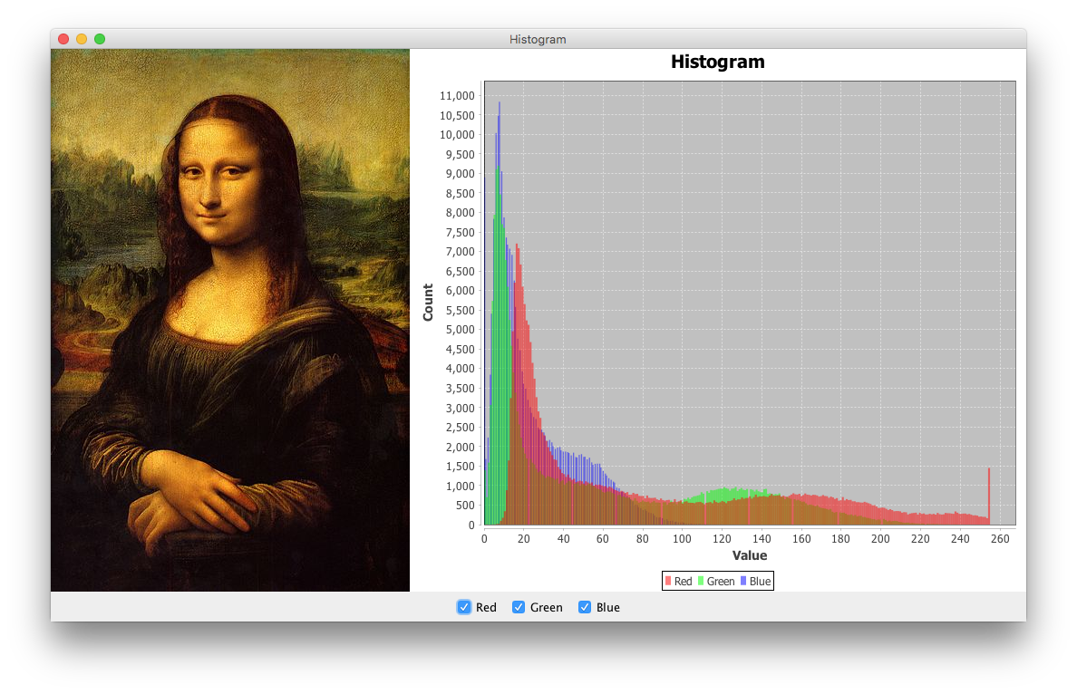

Assignment 7
#Import libraries
from urllib.requestimporturljoin
from bs4 import BeautifulSoup
import requests
from urllib.request import urlparse

# Set for storing urls with same domain
links_intern = set()
input_url = "https://www.geeksforgeeks.org/machine-learning/"
depth = 1

# Set for storing urls with different domain
links_extern = set()

# Method for crawling a url at next level
def level_crawler(input_url):
temp_urls = set()
current_url_domain = urlparse(input_url).netloc

# Creates beautiful soup object to extract html tags
beautiful_soup_object = BeautifulSoup(
requests.get(input_url).content, "lxml")

# Access all anchor tags from input
# url page and divide them into internal
# and external categories
for anchor in beautiful_soup_object.findAll("a"):
href = anchor.attrs.get("href")
if(href != "" or href != None):
href = urljoin(input_url, href)
href_parsed = urlparse(href)
href = href_parsed.scheme
href += "://"
href += href_parsed.netloc
href += href_parsed.path
final_parsed_href = urlparse(href)
is_valid = bool(final_parsed_href.scheme) and bool(
final_parsed_href.netloc)
if is_valid:
if current_url_domain not in href and href not in links_extern:
print("Extern - {}".format(href))
links_extern.add(href)
if current_url_domain in href and href not in links_intern:
print("Intern - {}".format(href))
links_intern.add(href)
temp_urls.add(href)
return temp_urls

if(depth == 0):
print("Intern - {}".format(input_url))

elif(depth == 1):
level_crawler(input_url)

else:
# We have used a BFS approach
# considering the structure as
# a tree. It uses a queue based
# approach to traverse
# links upto a particular depth.
queue = []
queue.append(input_url)
for j in range(depth):
for count in range(len(queue)):
url = queue.pop(0)
urls = level_crawler(url)
for i in urls:
queue.append(i)

OUTPUT
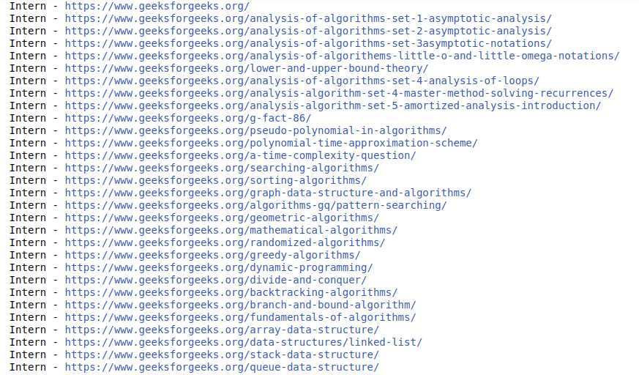
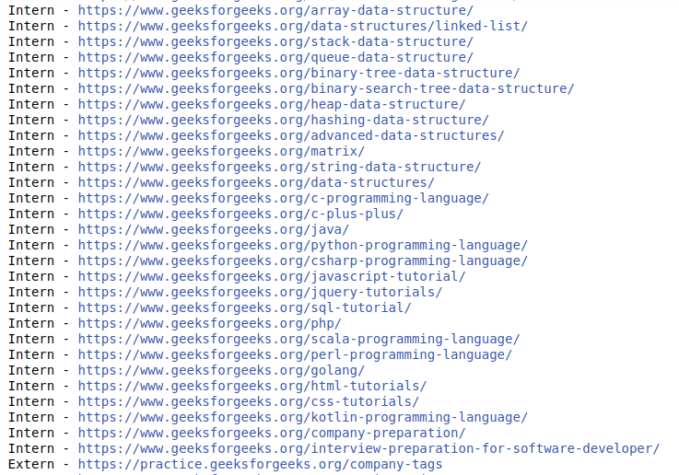

#assignment_8
importrequests
from pprint import pprint
def weather_data(query):
res=requests.get('http://api.openweathermap.org/data/2.5/weather?'+query+'&AP
PID=****************************8&units=metric');
returnres.json();
def print_weather(result,city):
print("{}'s temperature: {}°C ".format(city,result['main']['temp']))
print("Wind speed: {} m/s".format(result['wind']['speed']))
print("Description: {}".format(result['weather'][0]['description']))
print("Weather: {}".format(result['weather'][0]['main']))
def main():
city=input('Enter the city:')
print()
try:
query='q='+city;
w_data=weather_data(query);
print_weather(w_data, city)
print()
except:
print('City name not found...')
if __name__=='__main__':
main()

Output
Enter the city: Pune
Pune's temperature: 26.45°C
Wind speed: 2.1 m/s
Description: clear sky
Weather: Clear

